Reg. No. CODE: SPH2
Ph.D. COURSEWORK EXAMINATION – SEPT/OCT 2023
SUBJECt: biotechnology
SPECIALIZATION PAPER 2
TECHNIQUES IN PLANT BIOTECHNOLOGY
Time: 03 hours Maximum Marks: 50

Student Name: Drilipta Swain

Instructions:

i) Section A Compulsory
ii) Answer any four questions from Section B
iii) Each question carries 10 Marks

SECTION A

1. a) Explain the concept of clonal propagation
b) What do you understand by mutation breeding? Give examples (5 + 5 = 10)

SECTION B

Choose any four questions from this section. Each question carries 10 marks.

2. a) Explain the importance of ethylene and jasmonic acid in plant biotechnology.
b) Differentiate between callus and somatic embryo. Explain the process of callus induction. (5 + 5 = 10)

3. a) What are haploids and triploids? Explain the process of haploid production using an example.
b) Illustrate and explain the process of Agrobacterium-mediated transformation. (5 + 5 = 10)

4. a) Provide a strategy to develop transgenic plants with disease resistance.
b) What is marker-assisted selection? Explain its advantages with examples (5 + 5 = 10)

5. a) Describe Golden rice and write a short note on its production strategy.
b) Using an example, provide a strategy to develop plants accumulating high levels of secondary metabolites (5 + 5 = 10)

6. a) Explain cellular totipotency using suitable illustrations.
b) Assume you have transformed tobacco leaves with the following vector using Agrobacterium-mediated transformation. Provide a strategy to screen and select the transgenic plants expressing the vector (5 + 5 = 10)

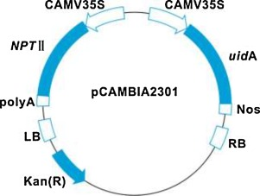

Legend: Kan=Kanamycin
NPT=Neomycin phosphotransferase (to metabolize neomycin/kanamycin)
uidA=any marker gene (fluorescent/colorimetric)

7. Explain the molecular basis of stress tolerance in plants. (10 Marks)

********

